**CHAPTER 4**

**CYBER PHYSICAL SYSTEMS IN CLINICAL SETTING**

**T P Kamatchi*, K Anitha Kumari, D. Priya**

**ABSTRACT:** Cyber Physical Systems (CPS) is a new generation of systems with integrated control, communication, and computation capabilities in the modern world. Just as the Internet changed the way people interacted with one another, cyber physical systems will change how people engage with the real environment. Currently, CPS research is in its infancy, and numerous research concerns and obstacles exist in areas such as electricity, health care, transportation and smart construction, agriculture, and others. The architecture of CPS and Wireless Sensor Networks (WSNs) for cloud computing for life support or healthcare and its application for monitoring and decision support systems are introduced in this article. The suggested CPS architecture is made up of three primary components: 1) communication, 2) computing, and 3) resource management for healthcare. Industry, agriculture, and hospitals are all being transformed by this type of integration, known as Cyber-physical Systems. CPS enables the systematic transformation of large amounts of data into information, revealing previously unseen patterns of degradation and inefficiency and resulting in an optimal decision-making system. This article focuses on current trends in hospital big data analytics and CPS development. Relevant concepts such as cloud computing, real-time scheduling and security models are thoroughly examined and explained. Finally, a health-care application section is offered, which is based on our long-running practical test bed. Many businesses and hospitals are confronting new opportunities and problems as Information and Communication Technologies (ICT) improve and advanced analytics are integrated into manufacturing, goods, and services. Finally, a case study using the CPS to construct intelligent machines is provided.

**Keywords:** Cyber Physical Systems, Smart sensors, clinical setting, Service oriented architecture, CPS architecture, CPS challenges, CPS characteristics, Security challenges

**1. INTRODUCTION**

**1.1 Cyber Physical Systems**

Systems that combine compute, networking, and physical operations are known as cyber-physical systems (CPS). There are feedback loops where the

\***Corresponding Author** **T. P. Kamatchi:** Lecturer, Dept. of Computer Networking, PSG Polytechnic College, CBE. E-mail: [tpk.dcn@psgpolytech.ac.in](mailto:tpk.dcn@psgpolytech.ac.in), [kamatchiperi@gmail.com](mailto:kamatchiperi@gmail.com)

physical processes influence the computations and vice versa. Physical processes are monitored and managed by embedded computers and networks. Such systems have far higher economic and societal potential than has been recognized, and significant investments are being made globally to advance the technology. The technology is based on the more established field of embedded systems, which studies computers and software in objects like cars, toys, medical equipment, and scientific instruments whose primary function is not computation. CPS blends the dynamics of physical processes with those of software and networking by using modeling, design, and analytical methodologies. Additionally, it offers abstractions for the integrated system.

**1.2 Definition of sensor**

Any type of input from the physical world can be detected by a sensor, which then responds to it. Light, heat, motion, moisture, pressure, or any of the many other environmental phenomena could be the specific input. Typically, the output is a signal that can be read or processed further after being translated into a human-readable display at the sensor position.

**1.3 Classification of sensors**

Different writers and professionals have categorized sensors in a number of different ways. Some are relatively straightforward, while others are intricate. An expert in the field may already use the classification of sensors that follows, although it is fairly straightforward.

The sensors are separated into Active and Passive categories in the first classification. **Active sensors** are those that need an external [3] power signal or an excitation signal. On the other hand, **passive sensors** produce an output response without the need for any external power signals.The other classification method is based on the sensor's method of detection. **Electric, biological, chemical, radioactive**, and other methods of detection are some examples.

The following classification is based on the input and output of conversion processes. **Thermoelectric, photoelectric, thermoelectric, electrochemical, electromagnetic**, and other frequent conversion processes are only a few.

**Analog** and **digital** sensors make up the last two categories for the sensors. Analog sensors generate an analogue output, often known as a continuous output signal, in proportion to the quantity being measured (often voltage but occasionally other quantities like Resistance etc.).In contrast to analogue sensors, digital sensors operate on discrete or digital data. Digital sensors contain data that is digital in nature and is utilized for conversion and transmission.

**1.4 Usage of sensors**

Several industries, including automotive, medical, aerospace, defense, and agriculture, use sensors for various purpose.

* **Position sensors** are employed to measure rotational or linear movement, displacement, and position. These are employed for steering angle measurement, wind direction measurement, ramp and bridge location, flight simulation, and throttle control.
* Pressure is measured with **pressure sensors**, which can be differential, gauge-style, or absolute. Transducers, commonly referred to as pressure switches or pressure transmitters, are the most widely used types of pressure sensors. Oil pressure, tyre pressure, car braking systems, oil pressure, fans, filters, and applications for diesel and engines are just a few of the applications for pressure sensors.
* The **force sensors**, sometimes referred to as load cells or weight sensors, are employed in scales for weighing purposes.
* By monitoring the amount of force being applied, **weight sensors** are renowned for providing an accurate weight measurement. The load sensors are utilized in tank weighing, on-boarding weighing, hopper weighing, and platform weighing, and counting scales.
* Temperature sensors are employed in the monitoring and detection of liquid, solid, and gas temperatures. It is the most often used sensor in houses and comes in a variety of sizes and shapes to serve diverse needs. This kind of sensor is utilized in home appliances, computers, electrical radiators, industrial equipment, motors, and surface plates.   Sensors are quite useful and are utilized in many pieces of technology that can be utilized every day.

**1.5 How do the sensors’ function?**

It is well known that sensors change their electrical characteristics in response to changing physical conditions. Electronic systems have been shown to be the most common means by which artificial sensors analyze, record, and transmit environmental data. It is possible to state that a sensor translates stimuli like sound, motion, heat, and light into electrical impulses in plain English. Before being sent to a computer to be processed, these signals are routed through a device that converts them further into a binary code.

The sensors are primarily employed as switches to control the flow of electric charges across the circuit. Electronics relies heavily on switches since they can be used to change the state of a circuit. Semiconducting elements used in sensors include transistors, diodes, and integrated circuits. The sensor circuits have these parts so they can serve as switches. In order to detect changes and things in the environment such as infrared radiation, laser light, infrared radio waves, and other waves like ultrasonic ones are commonly used in sensors. This is conceivable if they have a source of energy that helps them release radiation in the general direction of their intended target object.

It is referred to as an active sensor since the sensor detects the radiation after it is reflected back by the object. Passive sensors do not emit any radiation or waves of their own; instead, they pick up any radiation that the target objects emit, including heat, thermal infrared radiation, and radiation that is reflected off them from the sun [4].

**1.6 Diverse variety of sensors**

The list of numerous sensor types that are frequently used in various applications may be seen below. The purpose of each of these sensors is to measure a particular physical characteristic, such as temperature, resistance, capacitance, conduction, heat transfer, etc. Diverse of sensors and their description are given below:

**1.6.1 Temperature sensor**

The Temperature Sensor is among the most prevalent and well-liked sensors. A temperature sensor measures temperature changes by sensing the temperature, as the name suggests. Everywhere, including in computers, mobile phones, cars, air conditioning systems, factories, etc., temperature sensors are employed.

**1.6.2 Proximity Sensor**

A non-contact sensor that locates objects is referred to as a proximity sensor. The construction of proximity sensors can be accomplished by a variety of techniques, including as optical (such as infrared or laser), audio (ultrasonic), magnetic (Hall Effect), capacitive, etc.

Applications for proximity sensors include ground proximity in aircraft, mobile phones, cars (parking sensors), industries (object alignment), and others.

**1.6.3 Accelerometer**

A device that monitors the acceleration of any person or object in its immediate rest frame is an accelerometer sensor. It is not acceleration in coordinates. There are several applications for accelerometer sensors, including in wearable technology, smartphones, and other electrical equipment.

**1.6.4 IR Sensor (Infrared Sensor)**

Infrared sensors, sometimes known as IR sensors, are light-based sensors utilized in numerous applications, including proximity detection and object detection. In practically all mobile phones, IR sensors are employed as proximity sensors. Infrared or IR sensors come in two varieties: transmissive type and reflective type.

**1.6.5 Pressure Sensor**

To keep track of the pressure of gases or liquids in a pipeline, pressure sensors are frequently employed. A leak or a problem with flow control could be the cause of a sudden reduction in pressure.

**1.6.6 Light Sensor**

One of the most important sensors is the light sensor, sometimes known as the photo sensor. The Light Dependent Resistor, or LDR, is a basic light sensor that is now accessible. LDR has the property that it changes in resistance inversely with ambient light intensity, meaning that as light intensity increases, resistance decreases and vice versa.

**1.6.7 Ultrasonic Sensor**

A non-contact tool called an ultrasonic sensor can be used to gauge both an object's distance and its velocity. An ultrasonic sensor functions based on the properties of sound waves with a frequency greater beyond the range of human hearing.An ultrasonic sensor can calculate the distance to an item by measuring the time it takes for the sound wave to travel (similar to SONAR). A sound wave's Doppler Shift feature can be used to calculate an object's velocity.

**1.6.8 Smoke, Gas and Alcohol Sensor**

Smoke and gas sensors are among the most helpful sensors in applications that are safety-related. Smoke detectors are installed in almost all workplaces and businesses. These gadgets emit an alert when they detect smoke (from a fire).In industries, large-scale kitchens, and laboratories, gas sensors are more prevalent. They are able to detect a variety of gases, including methane (CH4), propane, butane, and LPG.As a safety measure, most homes now include smoke sensors, which can frequently detect both smoke and gas.

An alcohol sensor, as its name suggests, finds alcohol. In breathanalyzers, which assess whether or not a person is drunk, alcohol sensors are widely utilized. Law enforcement officers utilize breath analyzers to stop drunk driving.

**1.6.9 Touch Sensor**

Touch sensors are becoming a crucial component of our lives, despite the fact that are not given much importance. Whether the users are aware of it or not, touch sensors are present in all devices with touch screens, including laptops, tablets, and mobile phones. Track pads on our computers are another prominent place where touch sensors are used. As their name implies, touch sensors are used to track the touch of a stylus or finger. Touch sensors are frequently divided into capacitive and resistive types. Since they are more precise and have a superior signal to noise ratio, capacitive touch sensors account for the majority of touch sensors on the market today.

**1.6.10 Color Sensor**

These sensors are photoelectrical devices with the ability to both emit light and recognize the color of light reflected from objects. These sensors can distinguish between fundamental colors like red, blue, and green and can measure the amount of light reflected from an object. These also go by the name "color detectors."

Color sensors are able to illuminate an object with a wide range of wavelengths, light ratios, and primary color light intensities (red, blue, green, and white). The amount of light reflected and absorbed by the object depends on the light's intensity ratio.

**1.6.11 Humidity Sensor**

Weather monitoring systems frequently display temperature and humidity information. Because of this, figuring out the humidity is an essential task in many applications, and humidity sensors let us achieve this. Every humidity sensor calculates relative humidity often (a ratio of water content in air to maximum potential of air to hold water). Nearly all humidity sensors can also measure temperature because relative humidity depends on air temperature.

**1.6.12 Magnetic Sensor (Hall Effect Sensor)**

A Hall Effect sensor, often known as a Hall sensor, is a type of sensor that uses the Hall effect to determine the presence and strength of a magnetic field. The strength of the field has an inverse relationship with the output voltage of a Hall sensor. It bears Edwin Hall's name, an American physicist.

**1.6.13 Microphone (Sound Sensor)**

A sound sensor is a component that recognizes sound waves by their strength and transforms them into electrical signals. A sound sensor has a built-in capacitive microphone, a peak detector, and a sound-sensitive amplifier (LM386, LM393, etc.).

**1.6.14 Flow and Level Sensor**

Water flow sensors are installed at the water source or pipelines to track the flow rate of the water and calculate how much water passed through the pipe. Water flow rates are measured in liters per hour or cubic meters. A copper body, a water rotor, and a hall-effect sensor make up a water flow sensor. The rotor rolls as water passes through it at varying rates, changing speed as a result. Large industrial facilities, business and residential structures need a lot of water supplies. To fulfil this requirement, the public water supply system is utilized. It is necessary to measure the rate of flow of water in order to keep track of how much is provided and used.

A level sensor is a device that is used to keep track of, measure, and monitor the levels of liquids (and infrequently, solids). The sensor turns the observed data into an electric signal after detecting the liquid level. Although they can be found in many home products, such as ice makers in refrigerators, level sensors are most frequently utilized in the manufacturing and automotive industries. When submerged in a liquid, liquid level sensors, also known as liquid level switches, are intended to change state. They are employed to ascertain whether a liquid or oil is present in a container at a specific level. Level sensors are practical tools for determining the concentration of substances like liquids, powders, and granular solids. Level sensors come in a vast variety, and they are all used in various industries. Different level sensors can only be used for specific fluids, while others can be used with any liquid. When measuring substances that are in a container or in their natural state, such as rivers, level sensors are utilized.

**1.6.15 Tilt Sensor**

One of the most basic and cost-effective sensors currently available is the tilt sensor, which is typically used to monitor inclination or orientation. Historically, tilt sensors have been made of mercury (thus, they are occasionally referred to as mercury switches), however the majority of contemporary tilt sensors now include a roller ball.

**1.6.16 Passive Infrared Sensor**

Passive Infrared(PIR) sensor is a gadget that uses infrared radiation to detect motion. The sensor detects a sudden shift in infrared energy when a human walks by and sends a signal. Applications for PIR sensors include making a video camera start recording when someone enters a room or turning on lights automatically.

This passive approach is less trustworthy than "active" motion sensors, which either transmit light to a distant photo detector or bounce back a radar signal.

**1.6.17 Strain and Weight Sensor**

The change in length brought on by an external force can be measured by strain gauge sensors, also known as "strain gauge transducers," and turned into an electrical signal that can be displayed, recorded, and analyzed. This works because stretching or compressing a strain gauge sensor causes a change in resistance.

Using a weight sensor, a quality signal is transformed into a quantifiable electrical signal output. It is crucial for the proper selection of the weight sensor need to first taken into account the real working environment before employing the sensor. In addition, it affects the sensor's capacity to function normally, its safety and service life, and even the overall reliability and safety of the weighing instrument.

**Table 1.1Frequently used sensors and their description**

|  |  |  |  |
| --- | --- | --- | --- |
| **S. No** | **Name of the Sensor** | **Sensor Image** | **Usage of sensors** |
| 1 | Temperature Sensor |  | Automobiles, medical equipment, computers, kitchen appliances, and other sorts of technology all use temperature sensors. |
| 2 | Proximity Sensor |  | Proximity sensors are also used to measure the variation in distance between a shaft and its supporting bearing in addition to monitoring machine vibration. |
| 3 | Infrared Sensor |  | Gas warning devices, gas analyzers, medical gas measuring technology, flame detectors, and contactless precision temperature measurement all use infrared sensors. These instruments measure the intensity of infrared light within predetermined spectral regions. |
| 4 | Accelerometer |  | Vehicle acceleration can be measured using accelerometers. The vibration of vehicles, equipment, structures, process control systems, and safety installations can be measured using accelerometers. |
| 5 | Pressure Sensor |  | Pressure sensors can be categorized based on a number of characteristics, such as the pressure ranges they measure, the operating temperatures, or the types of pressure they measure. Absolute, gauge, sealed gauge, and differential pressure are a few different forms of pressure. |
| 6 | Light Sensor |  | Light sensors have been employed for many different purposes over the years, including solar cells, consumer electronics, vehicles, agriculture, etc. |
| 7 | Ultrasonic sensor |  | Most often, proximity sensors are combined with ultrasonic sensors. They are present in anti-collision safety systems and self-parking automotive technologies. Robotic obstacle detection systems and manufacturing technology both use ultrasonic sensors. |
| 8 | Alcohol and gas sensor |  | Similar to a standard breathalyzer, this alcohol sensor can detect the presence of alcohol on the breath. |
| 9 | Tilt Sensor |  | Users can identify orientation or inclination with tilt sensors. They are lightweight, affordable, low-power, and simple to use. |
| 10 | PIR Sensor |  | Passive infrared sensors, sometimes known as PIRs, can be used to detect the presence of people nearby. The output can be utilized to regulate the door's movement. |

**1.7 Smart Sensors**

A piece of technology called a "smart sensor" gathers data from the outside world, processes that input using built-in compute capabilities, and then sends the processed data to another device.Smart sensors make it possible to collect environmental data more precisely, automatically, and with less noise from inaccurate data. These gadgets are utilized in a wide range of situations, such as smart grids, combat reconnaissance, exploration, and many scientific applications, as monitoring and control mechanisms.

Another setting where the smart sensor is crucial and essential is the internet of things (IoT), which is gaining popularity. A unique identifier and the ability to send data over the internet or another comparable network can be added to nearly anything in this context. A Wireless Sensor and Actuator Network (WSAN) that has nodes that can number in the thousands and are individually connected to one or more additional sensors, sensor hubs, and individual actuators can be used to incorporate smart sensors.

To provide computer resources, low-power mobile microprocessors are frequently used. At the very least, a smart sensor needs to have a sensor, a microcontroller, and a communication system. A sensor is not considered to be a smart sensor if it only transmits its data for processing at a distance since the computational resources need to be integrated into the physical design.In addition to the primary sensor, a smart sensor could also contain other components. These components include, among others, transducers, amplifiers, excitation controllers, analogue filters, and compensation. A smart sensor also has software-defined elements that carry out operations like data conversion, digital processing, and communication with external devices.

**1.7.1 How do smart sensors work?**

A smart sensor connects a basic, unprocessed sensor to built-in computing capabilities, allowing the sensor's information to be processed.The element that offers the ability to sense is the base sensor. It could be built to detect pressure, light, or heat. Frequently, the base sensor will generate an analogue signal that needs to be altered before usage. This is where the built-in technology of an intelligent sensor is useful. The sensor's signal is transformed into a readable, digital format by the onboard CPU, which also removes signal noise.

Additionally, integrated communications capabilities in smart sensors allow them to connect to the internet or a private network. This makes it possible to communicate with other devices.

**1.7.2 How smart sensors are different from conventional sensors?**

In contrast to base sensors, smart sensors have an inbuilt Digital Motion Processor (DMP). Essentially, a DMP is merely a sensor that has a microprocessor built in. It enables the sensor to process the sensor data onboard. This could entail adjusting the data's normal distribution, removing noise, or applying other signal conditioning techniques. In any instance, a smart sensor converts data into digital form before communicating with any external devices.Simply described, a base sensor is a sensor that lacks a DMP or other computing resources that would allow it to process data. A base sensor's output is often raw and needs to be transformed into a usable format, in contrast to a smart sensor's output, which is ready for use.

Because smart sensors have native processing capabilities, they are often preferred to base sensors. Even so, there are situations where it might be more advantageous to use a base sensor. It will likely make more sense to utilize a base sensor rather than a smart sensor if an engineer is creating a gadget and need total control over sensor input. Because they have fewer components, base sensors are also less expensive than smart sensors.

**1.8 Key Difficulties in CPS**

Infrastructure and physical and technological processes must be invested in to get ready for cyber physical systems. Before starting such initiatives, the following issues should be taken into account:

* The interactions between the many parts of a cyber-physical system and the capacity to carry out several operations in parallel are significantly impacted by network performance in terms of latency, bandwidth, and dependability.
* The requirement for a network platform that is both versatile and manageable. When it comes to adjusting to various procedures and sensitively spotting issues and their causes (complex systems can trigger many failures from a single one).
* The systems must possess necessary properties such as self-configuration, self-adjustment, and self-optimization in order to increase their profitability, agility, and adaptability.

**1.9 Security Challenges in CPS**

Here are some significant difficulties faced by Cyber Physical systems in healthcare environment [16]:

1. **High assurance software** - Medical equipment uses high assurance software to automate hardware (like security locks) and other tasks. But it is widely acknowledged that MCPS cannot be kept secure given the importance of software development.
2. **Interoperability:** It's critical to ensure that all medical devices that interact with one another are certified, accurate, efficient, and secure.
3. **Context awareness:** Information about the patient shared during system contact can aid in the early identification of disease and can sound alerts in emergency situations in addition to helping to better understand the patient's general health.
4. **Autonomy:** The analytical skills that MCPS possesses can be used to expand the device's flexibility by enabling it to be used to treat patients in a way that is best for them at the moment. The loop must be swiftly and safely closed in this manner.
5. **Security and Privacy:** In order to manage and collect medical data, MCPSs must maintain a high level of security and privacy. Because of this, it's crucial to protect them from having their information compromised or altered. A patient may lose their privacy, face discrimination, be abused, or even suffer physical harm as a result of such an action.
6. **Certifiability:** A low-cost approach, such as acquiring medical device certification, is required by MCPS to demonstrate the dependability and safety of medical device software.
7. **Executable clinical workflows:** As medical devices become more interconnected and cooperative, to provide a (defined) patient with effective clinical services, MCPS can be developed and implemented more swiftly. [5]. The largest issue with commercializing MCPS is patient safety.
8. **Model-based Development:** Before creating a software system, it will be easier to evaluate a scenario's patient safety. This will also make it easier to create specifications for secure hardware that can be integrated into the scenario and its connections. These specifications can then be validated to ensure that the implementation is secure during deployment. Observe how MCPS model-based growth is used to do scenario analysis. Understanding how static and dynamic security checks interact is the most challenging.
9. **Physiological close-loop control:** People don't enjoy employing automatic control in healthcare for a variety of reasons, including controlling an application to a certain extent, giving complicated patients multiple therapies at once that may affect numerous distinct body systems, and so on. Keep in mind that every patient may experience a unique treatment plan.
10. **Patient modeling and simulation:** The system needs patient models to analyze how various circumstances and closed-loop control function. In closed loop PCA circumstances, it is crucial to comprehend how the drug is absorbed and to keep a watch on critical information like the patient's heart and breathing rates. The system ought to offer more straightforward solutions to the issue of designing and evaluating objects. These techniques may be used to simplify some complex models.
11. **Smart alarms and adaptive patients:** The majority of medical equipment is made to work for groups of patients (having similar medical conditions). Patients may respond to treatment in very diverse ways, which could be highly confusing and take a lot of time in MCPS. When a potentially harmful condition is discovered, for instance, the majority of medical gadgets may sound an alarm simultaneously. Medical gadgets may occasionally issue erroneous alarms. These types of incidents don't occur to caregivers. In order to effectively treat patients and gather information for Electronic Health Records (EHR), medical devices are already establishing solid network connections. In that circumstance, algorithms need to be created that are adaptable to the unique requirements of each patient. The system should intend to adjust the alarm thresholds in order to reduce false alarms by taking into account the patient's exercise history in the EHR. In order to reduce false alarms, "smart alarm services" will soon be available in medical equipment.
12. **User-centered design:** A caregiver who is overworked, stressed out, or who is having trouble utilizing a device may make mistakes. It could be required to design medical devices with users' wants in mind in order to guarantee that they are satisfied with how the gadget functions. Examples of this include a user-friendly interface, interactive ways for users to learn how to use the device if they get stuck, and ways to correct mistakes.
13. **Infrastructure for Medical-Device Integration and Interoperability:** Only one business is actively working on Distributed Medical Communication Protocol Systems (MCPS) that use a proprietary communication protocol (making regulatory approval simpler, but reducing the benefits of inter-device communication). When it comes to MCPS, numerous open standards (interconnectivity) are regarded as the norm (including basis for interoperability of medical devices). However, if these standards are to be employed on simple to create and use platforms, they must be more effective. Medical device manufacturers must go by specific guidelines when creating their products in order to get the most out of them and have them interact and integrate with one another.
14. **Compositionality:** Techniques like temporal induction can help keep MCPS systems secure by making it easier to think about how linked devices interact with one another in a specified way. Identifying potential unexpected interactions between medical devices is the most challenging task in this scenario. Due to their proximity, medical devices that are administering several therapies to the same patient may experience radio interference. By altering how the body reacts to them, treatments can interact with one another. An illustration of this is "mixed criticality." The amount of Mean Arterial Pressure (MAP) being measured depends on where the patient and sensor are in respect to one another. The patient's bed is raised, which is a Class I medical device—the least significant in the FDA classification—which causes a change in the MAP measurement. If the MAP sensor is a part of a system that keeps track of things like a patient's vital signs, the sudden change can cause false alarms or other unfavorable behavior. The monitoring system was given more environmental data using this problem. It's challenging to try to create these devices while taking these factors into consideration.
15. **Security and privacy:** Generally speaking, networking capabilities that medical devices have when they connect to the internet could lead to security and privacy lapses when combined. Patients could be harmed or perhaps die if the MCPS network is breached (by re-programming devices). Currently, it is possible to severely restrict the operation of devices that may be observed through the network interface but cannot accept any commands from the network. It might be difficult to strike the right balance between mobility and safety (for MCPS). Problems with electronic medical records must be resolved with workable solutions.
16. **Verification, Validation and Certification:** Validation is completed before verification and certification, which are completed once the design is complete. Now, things are as they are. The "design for verification approach" can be used to obtain the proof of the verification process, making scaling for verification easier and easier. Another strategy that enables verification to occur early in the design phase and raises the amount of certainty that can be provided through verification is model-based generative techniques. Keep in mind that medical device run-time components can be developed.

**2. SENSOR NETWORKS AND TRANSMISSION TECHNOLOGIES:**

Sensor networks build smart technology and systems that improve people’s life. The components of a sensor network include sensor nodes, sensors, the gateway, and a management node. The four topologies of sensor networks are point to point, star, tree, and mesh. At the same time that sensor node operations are becoming more complex, so are the requirements for high-quality data processing. The number of nodes in a sensor network might range from a few to thousands. Sensor networks are classified based on their size, as discussed below.

**2.1 Types of Networks:**

**2.1.1 Body Area Network (BAN):**

A very small network of sensors implanted inside the body, on its surface, or all around it makes up a body sensor network, or BAN. BSNs are influencing how people use computers and playing a bigger part in the domains of social welfare, sports, and medical care. It is a brand-new approach to disease surveillance, universal health care, and illness prevention.

**2.1.2 Personal Area Network (PAN):**

Personal Area Network (PAN) is a network used to connect a person's personal electronic devices and meet their needs. The size of a PAN ranges from a few centimeters to a few meters. A PAN is larger than a BAN but smaller than a LAN. One of the most common real-world examples of a PAN is Bluetooth connection between a mobile phone and its headset.

**2.1.3 Local Area Network (LAN):**

Local Area Network (LAN) is a type of network used to connect nodes within a building or between buildings within typically one-kilometer radius. Data transfer rate supported by LAN ranges from ranges from 100 Mbps to 1000 Mbps. Users in one LAN can get connected to other LANs by interconnecting the networks using routers.

**2.1.4 Metropolitan Area Network (MAN):**

A Metropolitan Area Network (MAN) is a type of network used to connect sensor nodes within a metropolitan area generally covers the size of a city. CPS based remote monitoring applications is an example of MAN since it connects the hospital and patients at their houses with in a city.

**2.1.5 Wide Area Network (WAN)**

 The communication range of conventional sensor network technology is constrained (typically 10–100 m).WAN is a Wide Area Network that operates beyond the geographic scope of LAN and MAN. It can be used to connect multiple LANs in different parts of the country together.WAN is classified as Public WAN and Private WAN based on the usage.

**2.2 Transmission technologies:**

A sensor network comprises a group of small, powered devices, and a transmission media used to connect all sensors. Sensors can be connected in various ways for data transfer from the machine to the computer that has the software for analyzing and taking action on the data. The node density may increase to the point that a node has several thousand neighbors within their transmission range when collecting high-resolution data. [7]. Transmission technologies can be divided into two types: Wire and Wireless.

**2.2.1WiredTransmission:**

A wire is used in wired communication media to transmit data from a source to a destination. Additionally, compared to wireless, wired media has a faster connection speed. Other external interferences are less likely to affect these connections. Adopting wireless technologies at the sensor level has additional benefits, including continuous, high-resolution, universal sensing, support for mobility, redundancy, and compactness. Some of the wired transmission technologies as shown in Fig 2.1 are discussed in the following sections.

**2.2.1.1 Controller Area Network (CAN) bus:**

Controller Area Network is referred to as CAN. The CAN bus is a serial communication bus built for dependable operation in challenging conditions. As an illustration, it primarily supports the networking of several electronic control units (ECUs) in automobiles. Unshielded Twisted Pair (UTP) cabling, which is made for dependability in situations with electromagnetic noise, is used to implement CAN.

**2.2.1.2 RS232:**

RS232 stands for "Recommended Standard 232".It is a serial communication system and can send data bit by bit. It supports distances up to 50 feet and data rate of 1.492kbps. It is slower than Ethernet.

**2.2.1.3 RS485:**

When several devices need to be connected to one another for a system, RS-485 defines the electrical interface and physical layer that are more commonly utilized in industry. With a rate of 1.492 kbps, it is utilized for serial transmission up to 50 feet. It is only employed when our sensor is a slave to the control system, which acts as the relationship's master. Computers, PLCs, microcontrollers, and intelligent sensors are other devices that frequently use the RS485 standard in scientific and technological applications.

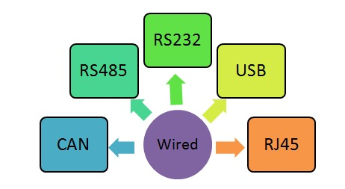

**Fig:2.1 Types of Wired media**

**2.2.1.4 USB:**

The USB interface is a plug-and-play (PnP) interface that enables the addition and removal of devices without the need for manual configuration. The overall bandwidth and support capabilities are the two most crucial components of the USB interface. It has a total bandwidth of 1.5 MB per second and can accommodate up to 127 peripherals.

**2.2.1.5 RJ45:**

RJ stands for registered jack (RJ). It is a network interface used to connect data communication equipment’s and data terminal equipment’s in a network.They can handle a bandwidth of up to 100Mbps. RJ45 connectors can be used for both short term and long term distance. RJ45 connectors are used with Unshielded Twisted Pair (UTP) cables to connect devices in a LAN.

**2.2.2 Wireless Transmission:**

Wireless media can send data through radio waves or infrared light on computers. There are of several more types of wireless media [1], and each one has its own capabilities and is used for different things. Sensor and computer communication is handled by the wireless communication module in the physical layer. The different types of wireless transmission technologies are shown in Fig 2.2

**2.2.2.1 Wifi:**

WiFi is an IEEE 802.11 standard. It is used to create a wireless LAN with or without using an Access point (AP). In the 2.4 GHz range, WiFi offers transmission speeds of 1 or 2 MB per second. The following topologies are supported by WiFi:Adhocnetwork without using an AP and Infrastructurenetwork using an AP. Service set identifier (SSID) is a sequence of characters used to identify a wireless local area network (WLAN).

**2.2.2.2 3G/4G/5G:**

The third, fourth, and fifth generations of cellular technology are known as 3G, 4G, and 5G, respectively. The main distinction between each generation is based on their capacities. Both 4G and 3G technology is supported by the majority of modern cell phone models. The Next Standard is 5G With a limited rollout, 5G is a wireless technology that aims to outperform 4G.

* **UMTS:** For networks based on the GSM standard, UMTS (Universal Mobile Telecommunications Service) is a third-generation (3G) technology. It can carry text, digitized speech, video, and multimedia data at speeds up to 2 megabits per second (Mbps).
* **LTE:** Based on the GSM/EDGE and UMTS/HSPA protocols, LTE (Long-Term Evolution) is a fourth-generation (4G) technology for mobile devices and data terminals. Compared to third-generation (3G) technology, it offers more network capacity and speed for cell phones and other cellular devices.

**2.2.2.3 Global Positioning System (GPS):**

The Global Positioning System, also known as GPS, is a system of satellites used for global navigation that synchronizes time, speed, and location. GPS is widely used. There are three parts that make up GPS: satellites, ground stations, and receivers. If a GPS-enabled object moves from one location to another, the GPS receiver will determine the direction and speed of the movement.[8].

**2.2.2.4 Zigbee:**

Zigbee is a standards-based wireless technology developed to enable low-cost, low-power wireless machine-to-machine (M2M) and internet of things (IoT) networks.

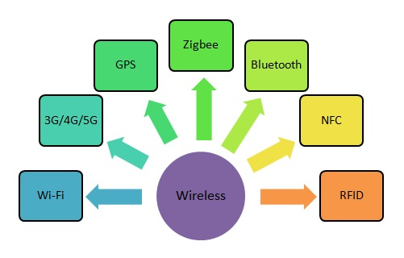

**Fig:2.2 Types of Wireless media**

Zigbee is an open standard that works well for low-data-rate, low-power applications. It supports the mesh network design and offers low-cost, many data transmission options while consuming little power. It is simpler to install and less complicated than Bluetooth. Zigbee is more dependable and supports a lot more nodes.

**2.2.2.4 Bluetooth:**

Bluetooth is an IEEE 802.15 standard. It is wireless PAN used for short range communication.The Bluetooth devices exchange data between them using the radio frequency in the ISM band ranging from 2.402 GHz to 2.48 GHz. Blue tooth is also called as cable replacement technology and supports 10m range [9]. Bluetooth provides the following three low power modes for power management: hold, sniff, and park modes.

**2.2.2.6 RFID:**

Radio-frequency identification is referred to as RFID. It is a wireless technology that uses the electromagnetic waves emitted by tags affixed to things to identify and track them. The components of RFID system are RFID tags and RFID readers. RFID tags are nothing but an IC with an antenna which store some information about the object that can be modified.

**2.2.2.7 NFC:**

NFC (Near-Far Communication) is an evolution of [RFID](https://www.androidauthority.com/what-is-rfid-975910/) technology.Both RFID and NFC operate on the principle of inductive coupling, at least for short-range implementations. The NFC system functions at a close range, or proximity. On the other hand, RFID can scan tags up to 10 meters away.

**2.2.2.8 Comparison of Wireless transmission technologies:**

The comparison of different types of wireless technologies are tabulated in the table 2

**Table 2.1 Comparison of Wireless Technologies**

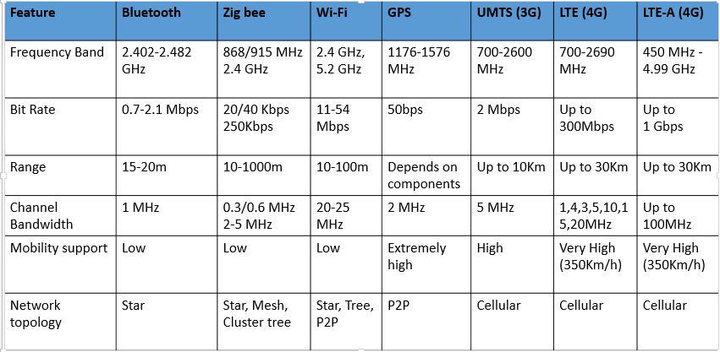

**3. ARCHITECTURE OF CYBER PHYSICAL SYSTEM**

Applications built on the highly innovative CPS platform are used in a variety of industries, including the automotive, home appliance, medical, and industrial. The achievement of all these applicationsmainly relies on design parameters considered for CPS architecture [10].

* 1. **Design requirements of CPS architecture**

The requirements for a cyber-physical system are typically specified in terms of following major design parameters[3], namely, reliability, accuracy, latency, scalability, interoperability, Quality of Service, security and privacy.

**3.1.1 Reliability:**

The reliability of CPS is mainly dependent on the selection of hardware, software and network. Since CPS is widely used in safety-critical systems,reliability cannot be neglected.

**3.1.2Accuracy:**

Accurate data is essential for providing high quality service. Accuracy of the CPS system enhances predictability and strategic decisions for business growth.

**3.1.3 Latency:**

For CPS applications, data should be made available more promptly. The dynamic interactions between sub-systems would be significantly impacted if data transfers take longer in terms of latency, bandwidth, and dependability.

**3.1.4 Scalability:**

From a small body area network to a wide area network, CPS ought to continue to be efficient and react more quickly.

**3.1.5 Interoperability:**

Since CPS uses a wide variety of sensors and actuators and multiple platforms, they must be able to interact with each other to deal with massive amount of data being generated.

**3.1.6 Autonomy:**

The computational intelligence of CPS contributes more to increase the autonomy of the system and minimize human intervention safely and effectively.

**3.1.7Security and Privacy:**

With the usage of the massive number of sensors in CPS during the contact with the physical world and humans, the requirements for security and privacy increase significantly.

**3.1.8 QoS:**

Data should be delivered within time period for real time applications. However, reliability and security of CPS affects the quality of the service experienced by users.

**3.2 Generic architecture of CPS:**

CPS is a collection of physical and computational components for providing integrated and compatible frame work to sense the changing state of the real world. The generic architecture of Cyber Physical system has shown in Fig 3.1defines how sensed data is communicated between the sub-systems internally and externally. Sensors and actuators are two vital components of CPS. They both act as mediators between the embedded system and the physical environment. Actuators are output devices used to respond to and influence the reported circumstances, whereas sensors are input devices used to collect information about common physical variables such as pressure, heat, distance, light, etc. [11]. Though actuators and sensors serve a different purpose, they often rely on each other to perform certain tasks.

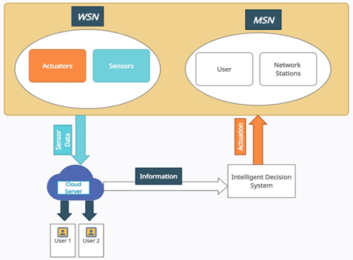

**Fig3.1:Generic architectureof CPS**

Data collected from various sensors are processed and converted into digital information at sensor nodes. Sensed datais usually sent wirelesslyalong different routing paths in wireless sensor network to cloud storage and stored. The decision system converts the information stored on the cloud into high level knowledge so as to predict the trend, find actionable insights and scope of long term growth of CPS. Upon making decision using sensed data, the expert system will actuate a response system to trigger variety of events and make appropriate changes the cps physical events.

**3.3 Service Oriented Architecture (SOA) for CPS:**

[2] Literature discusses the difficulties in designing the CPS architecture which are highly populated, heterogeneous, distributed, and loosely-coupled and are typically system-of-systems.SOA is an architectural approach used to achieve efficient management and operation of CPS systems. In this architecture, CPS applications make use of services available in the network. Nowadays many applications use inbuilt functions to run. For example, an application requires GPS; it uses the inbuilt GPS functions of the device itself [12].

SOA is a software architecture based on the concept that a system consists of a set of services in which one service may use another and applications may use one or more services based on their need.SOA based architecture consists of service components such as service description,service composition, service registry,service discovery and service monitoring as shown in Fig.3.2.

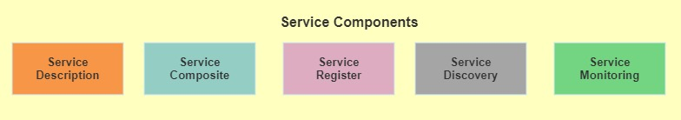

**Fig.3.2Service components in SOA**

* **Service description:** It specifies metadata which can be used to describe the characteristics of services that are deployed on a network.
* **Service Composition:**Service composition is used to collect the services available and combine many simple services into to a complex service.
* **Service registry:** It is used to provide details about the available services in an SOA implementation. It helps application developers to determine the models used for a specific application. Hence it makes fast and easy communication between the service components and minimize human intervention.
* **Service discovery:** It is used to discover a service, its status, and its owner so that the services can be reused without service interruption.
* **Service Monitoring:** It is used to monitor all services and reference binding components used in the entire SOA with CPS applications.

  Applications based on CPS are developed in large part because to SOA.Fig3.3 illustrates the architecture of CPS with SOA.In this architecture, services use common interface standards and an architectural pattern to build new applications rapidly. This simplifies tasks of application developer who upgrades the existing system into a modern system.

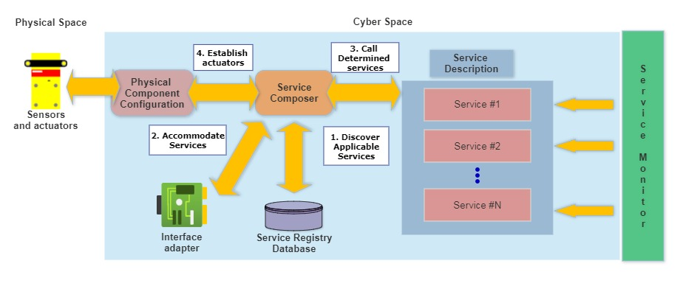

**Fig. 3.3 SOA based CPS architecture**

**3.3.1 Advantages of SOA:**

* SOA supports service modularity. Hence reliability of CPS increases rapidly since testing of services can be done more easily as compared to large applications.
* Complex CPS applications can be developed by combining two or more services that are already available.
* SOA increases reusability of services and decreases the time and cost required for development.

**3.4 CPS Layer model:**

CPS layered architecture extends and adapts existing IoT and WSN architectures. All these technologies divides the CPS architecture [4] into four layers namely physical/sensing layer, networking layer, decision (analyzing) layer and application layer. The layer model of CPS is shown in Fig.3.4. Usually, all these layers will need to deal with security and privacy concerns.

**3.4.1 Physical layer**

This layer deals with sensors and actuators used in the CPS. The main responsibility of physical layer is to collect the data from various sensors and send them to further processing layers.There are variety of sensors available in the market for CPS applications. While designing the network, need to consider the type of interface supported by the sensor device. Because many sensors come with different types of interfaces[13].A CPS application is needed to be designed in such a way that it should accommodate the different types of sensors and interfaces based on the requirement in a safe and secured manner.

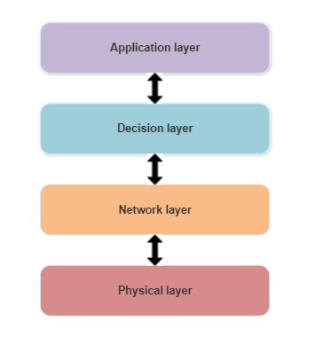

**Fig:3.4 CPS Layer model**

**3.4.2 Network layer**

The network layer converts data into packets and forwards packets from source to destination through the best path.Routing of data from node to node is taken care by network layer.All devices in a CPS system need to be interconnected to send/receive data to/from other CPS components. Although installing and configuring wired network devices is simple, many applications make use of technologies that enable wireless communication at the device level. The examples of wireless technologies are Bluetooth, Wi-Fi, Cellular, UWB, Zigbee, etc.

**3.4.3 Decision layer**

Software applications developed for CPS ensures device functionality and other performance metrics such as safety and efficiency. The reliability ofCPS system rely mainly on the selection of software tools chosen for system development. CPS middleware helps sensor nodes to coordinate their activities and share the resources of the system. Data analytics facilitates intelligent decision-making and allows the formulation of effective business strategies.

**3.4.4 Application layer**

The application layer is responsible for providing different types of services to end users. It can handle the processes based on information obtained from middleware. CPS has created a new reality space with innovative applications and processes in the areas of Healthcare, transportation, smart grid, etc., and eliminates the gap between real and virtual space.

**3.5 CPS architecture for Clinical Setting:**

 CPS for clinical settings is nothing but the integration of a network of medical devices and suitable software applications.These systems empower hospitals and health systems to achieve performance excellence.The generic CPS architecture can be used as a reference to design a CPS application for Clinical Setting. It discusses about the interconnection of sensors, how data is acquired from sensors, the various methods used for data processing and visualization. Fig 3.5 presents the CPS architecture for monitoring Clinical Settings to achieve high –quality healthcare [14].

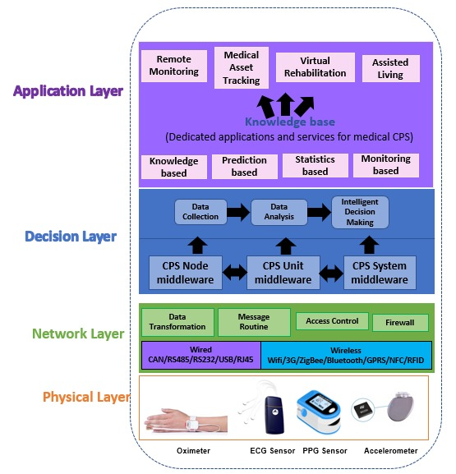

**Fig 3.5 Architecture of CPS for Clinical Settings.**

**3.5.1 Physical / Sensor layer**

This layer is responsible for detecting different types of healthcare sensors connected in the network and collecting data from them. There are manyhealthcare sensors such as EEG sensor, EEG sensor, PPG sensor, RFID sensors,etc. available in the market. The sensors are selected as per the requirement of applications. Every sensor comes with different types of interfaces. A well-definedCPS system should accommodate the different types of sensors and interfaces based on the requirement in a safe and secured manner.

**3.5.2 Network layer**

This layer is responsible for the following functions: Data transformation, message routing and access control. It is used to connect the network devices and different types of networks together. The medium through which data is transferred from the physical layer to the network layer can be wireless and wire-based. Hence, it is extremely sensitive to attacks from the attackers. Hence Access Control policies are a crucial component of Secure Firewall deployment in preventing malicious or unwanted data traffic.

**3.5.3 Decision layer**

This layer is used to collect, store and analyze medical data from network layer. In order to hide from the user the variety of the underlying networks, hardware, operating systems, and programming languages, this layer offers a programming abstraction to the application. Generally, most of the healthcare applications generate large volume of data in their routine, they require more sophisticated algorithms for intelligent decision making. The data collected from the monitoring devices are sent to the middleware built on the wireless sensor network. This middleware is used to enhance the development of CPS applications. For instance, the medical data can be used to analyze and estimate the state of the patient’s health automatically and instruct drug delivery system to start treatment immediately.

**3.5.4 Application layer:**

This layer defines all applications in which CPS has been deployed. It is the interface between the sensors and the users. CPS based applications for Clinical Setting can be divided into the following four groups based on the technical complexity [5].

1) Statistics-based applications: Healthcare CPS utilize statistics to offer quality care, ensure safety, promote health, and advance evidence-based decisions to diagnose the diseases accurately.

2) Monitoring-based applications are used where real time analysis is essential: For example, Intensive care units (ICUs) in the hospital, assisted-living homes, remote monitoring and e-health, Virtual rehabilitation centers.

3) Knowledge-based applications: These applications are developed mainly based on big data. By taking advantage of cutting edge technologies such as AI, ML, AR, and VR the system can optimize the procedures to diagnosis and treat the diseases and identify side effects.

4) Prediction-based applications: Healthcare organizations can use prediction based applications to calculate risk scores of individuals and provide personalized and accurate treatment options.  For example, Treatment for obesity and high blood pressure patients

**3.6 Enabling technologies for healthcare cyber physical systems**

Modern technologies like digital twins, IoT, big data, cloud computing, blockchain, artificial intelligence (AI), machine learning (ML), robotics, and AI have considerably boosted the use of healthcare cyber-physical systems as shown in Fig 5.1.IoT makes a patient’s life easier and plays a vital role in healthcare. IoT in healthcare has fully converted patient’s life style and alleviated many problems faced by patients who need constant care. Hospitals can provide a better service increasing the role of robots in Patient care.

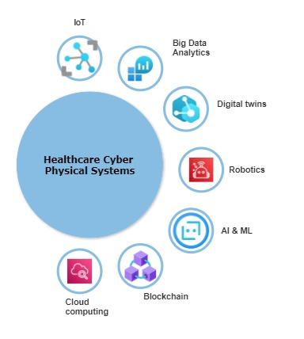

**3.6 Enabling technologies for Healthcare CPS**

Detecting chronic disease in earlier stage can increase survival of patients.Digital twins (DTs) have gained popularity in Medical diagnosis to detect the diseases on their earlier stages by analyzing physiological and behavioral data.Cloud computing techniques enable physicians to access real time data and store massive amount of health records. Big data in CPS can be used to categorize patients based on their medical data into hoe risk to low risk levels. AI and ML based CPS applications can be used to predict future health conditions of the patients with accuracy. In addition to that, the block chain is a valuable option to manage the large volume of data processed by the healthcare industry because it offers security, speed, availability, accessibility, and more.

**4. IMPLEMENTATION OF CPS IN CLINICAL SETTING**

**4.1 Cyber Physical Systems in Clinical Settings**

There is an urgent need for new, more capable gadgets due to the quick growth of various medical systems. Systems that include embedded hardware, software to operate those devices, and communication channels for interaction are known as medical cyber-physical systems. Due to a rise in scale and complexity, CPS in CS development requires new design, verification, and assessment techniques. Model-based development, physiological close loop control, adaptive patient-specific algorithms, smart warnings, user-centered design, and infrastructure for medical integration and interoperations are among the difficulties associated with developing these kinds of systems. Patient monitoring, analgesic infusion pumps, and implant sensor devices are just a few examples of the application scenarios for CPS in healthcare [15]. A framework for modeling and analyzing cyber physical and medical systems has been proposed to confirm the security of various applications. The experiment used an analgesic infusion pump control algorithm to maintain a constant medication concentration in the blood. These systems serve as typical closed loop system examples. A command issued from cyberspace will cause a physical action to be performed, and any modification to the physical world will have an immediate impact on the cyber world. The CPS framework offers recommendations for building CPS for usage in commercial or medical purposes. The physical world and the digital world are the two main elements of this CPS paradigm. The proposed structure's workflow is depicted in Figure 4.1, which outlines how to build a CPS system from data collection to value creation. The levels of Smart Connection, Data to Info Conversion, Cyber, Cognition, and Communication make up the framework. To work on each component, a cycle of step-by-step communication will be used.

**Fig 4.1 CPS general integration**

**4.2 Mechanism makes up Cyber Physical Systems**

A cyber physical system is an amalgamation of many systems with the primary goal of controlling and interacting with a physical process and, through feedback, quickly adapting to changing circumstances. Cyber-physical systems are typically interconnected with one another and with the virtual world of international digital networks. At the nexus of networks, cybernetic computing, and physical processes, they are produced.

**4.3 How does a cyber-physical system operate?**

Cyber physical systems are a collection of interactive systems backed by intelligent machines that, when coordinated and managed by a central authority, communicate operational data to trained personnel.In this way, industrial processes function autonomously while engineers address potential issues and potential fixes in-person within this cybernetic replica. Fig 4.2 depicts CPS workflow cycle

There are two different kinds of acts done:

* Corrective decisions: process optimization, problem solutions, etc.
* Planned actions: process automation, predictive maintenance, etc.

**Fig 4.2 CPS Workflow cycle**

**4.4 Implementation of Cyber physical systems**

Implementing cyber physical systems requires taking into account five steps in order for them to improve industrial processes. Figure 4.3 depicts the overall framework or architecture of CPS at various levels.

* **Connection level:** The data produced is the primary source for an intelligent factory. It is crucial to have a highly connected, data-intensive facility that runs on a 5G network that is 100 percent secure and built for industrial use.
* **Conversion level:** This architecture's central hub is where data analysis and knowledge transformation take place. Recently, the creation of smart algorithms and data mining techniques has received the majority of attention. These methods can be used with a variety of data sources, including: from data about machines and processes to data about businesses and enterprise management
* **Cyber level:** networked items must be implemented carefully so that data is processed and turned into information using algorithms.
* **Cognition level:** In order to turn machine signals into information and be able to compare that information to other outcomes, they must be processed. At this stage, the machine keeps track of and diagnoses its own issues, alerting it to prospective issues.
* **Configuration level:** Based on the data, the machines modify how they operate. They can adjust their operations in response to workloads or problems.

**Fig 4.3 CPS at various levels**

**5. EMERGING CYBER-PHYSICAL SYSTEMS IN CLINICAL SETTINGS**

**5.1 CPS based Hospital Asset and Patient Location Tracking System**

In Health care applications, Time is one of the major factors that impact patient experience the most. For instance,any delay in giving treatment can raise risk of death. Technology can help hospital administration to improve patient over all experience by increasing automation and decision support system. For instance, there are many CPS-enabled solutionsadopted byhospitals to offer high quality treatment with other benefits such as reduced waiting time, ensuring patient safety, etc.. RFID based hospital asset tracking system [6]as shown in Fig.5.1 plays a vital role in tracking lifesaving equipment when trauma patients are treated at emergency wards. Patient tracking module has the ability to track patients moving from place to place using their RFID tags. It can also monitor the waiting time of each patient at various places such as scan centers, testing laboratories and at canteens and ensure safety of patients till they leave the hospital. GPS tags can also be incorporated in this system for outdoor tracking. A suitable mobile application is created for medical staff and administrator to view the location of medical equipment’s easilyand make decisions quickly.

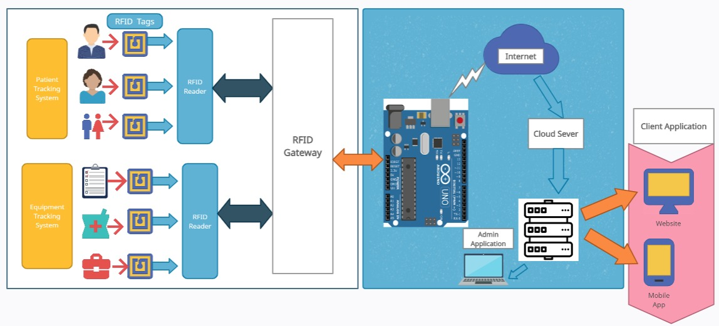

**Fig.5.1: Block diagram of CPS based Hospital Asset and Patient Tracking System**

**5.1.2 Working of the Asset tracking System:**

**5.1.2.1 Asset Tracking Module:**

The hospital assets are equipped with RFID tags. RFID Readers should be installed in the hospital areas such as consultation rooms, path ways and laboratories so that they can scan RFID tags and send the information about the location of the assets. Electromagnetic waves emitted from RFID readers may interfere medical equipment’s near RFID readers. Hence, while designing the layout, distance between medical equipment’s and RFID devices need to be considered. One or more RFID tags can be read simultaneously without close proximity or direct line of sight requirement.

All the RFID readers are interfaced with Arduino module through RFID gateway. On the other side, Arduino Board is connected with the cloud using Wi-Fi. The Cloud environment is best suited for the medical data as it offers both storage and security with latency and privacy, as per the need of the hospital. Hence the data gathered by RFID readers are sent and stored in Cloud servers. The cloud computing technology connects hospitals, patients, insurance companies, and medicine suppliers, etc. into a large healthcare eco system.

Whenever a hospital equipment is needed, the doctor or any medical staff can find the location of the nearest available equipment easily using the Map provided in the client application. The cloud acts as a Data base for storing all the information, which can be accessed by the client through Internet from any accessible points. This system also helps hospital staffs to conduct asset management and find bottlenecks in internal hospital processes and optimize investments in inventory control and management.

**5.1.2.2 Patient Tracking Module:**

Whenever a patient visits the hospital, he is given a RFID tag. This tag is unique for every patient, wherein which helps us to identify concerned patient’s information. An RFID site survey of hospital premises should be conducted before installing and configuring any RFID readers. RFID site survey report can be used to predict the propagation of radio waves while detecting the presence of interfering signals so that RFID readers can be placed on perfect locations. It is also important to protect the RFID readers from damages.

As a patient moves from one place to other, RFID readers installed on that area within the hospital area will detect the tags and receive the information about tags location and transfer it to the Arduino so that it can be sent to the cloud server and stored for further calculation. The waiting time is calculated by finding difference between registration and treatment time. The system can easily identify and evacuate newborns, bedridden patients under hazardous circumstances and verify that they have left that endangered area .More over this system helps hospitals to predict patient flow, analyzing the data about past incidents to provide better service and gain the loyalty of patients.

CPS based health care solutions are dealing with most private and vulnerable information such as patient data, medical conditions, and so on. In this regard, CPS based applications for Clinical setting must be implemented with security to protect medical data from hackers and other cyber security threats.

**5.1.3 Advantages**

* Improve visibility into medical asset’s location and availability
* Reduced waiting time for patients’ satisfaction
* Find idle assets and improve Asset utilization
* Quickly conduct accurate counts
* Prevent loss and theft of movable assets

**5.1.4 Similar CPS Applications in Clinical Settings**

* Newborn monitoring system
* Hospital Inventory Control and management
* Smart Cloak room
* Virtual Rehabilitation Centers for physiotherapy

**5.2 Medical CPS (MCPS) and Big Data Platform**

This is a huge data processing platform for MCPS that blends the real world with a totally elastic, dynamic, temporary cyber environment for the sake of making healthcare decisions. This structure can lower hospital costs and make it easier for professionals to check on patients routinely. The patient's body is connected to a number of sensors as part of a remote healthcare monitoring system in order to measure various physiological parameters, including the ECG, oxygen saturation, and pulse rate. The doctors then send these data to a remote application server for analysis to ascertain the patients' health status.

**5.3 LiveNet**

Investigation of disease-specific LiveNet activities. It is a smartphone platform that tracks motions in real-time for persons with Parkinson's and epilepsy. The mobile wearable PDA platform, software architecture, and real-time context engine are the system's main building blocks.This method is effective in differentiating between a range of symptoms in people with Parkinson's disease and epilepsy, such as bradykinesia and hypokinesia.

**5.4 HipGuard**

HipGuard is a posture analysis programme made to be used for eight to twelve weeks after hip replacement surgery in order to keep an eye on posture. Seven sensors that are integrated with the system are placed strategically close to surgical sites. The data processing unit can determine the hip's position and the weight being applied to it after receiving the collected data from the sensors. If any risky motion or weight is put on the operated hip, an alarm is set off, and physicians are informed. Fig 5.2 shows the Hipguard device

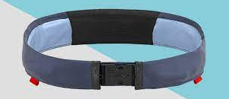

**Fig 5.2 HipGuard**

**5.5 AlarmNet**

A wireless biosensor network system prototype called AlarmNet measures heart rate, pulse rate, oxygen saturation, and ECG. Environmental factors like humidity and temperature provide geographical contextual information. The system also takes into account query management, privacy, and power management. Data gathering and storage are connected by a gateway. Additionally, this device has a graphical user interface to help medical practitioners monitor patients' vital signs. Fig 5.3 depicts AlarmNet device.

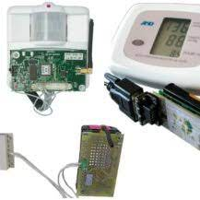

**Fig 5.3 AlarmNet**

**CONCLUSION**

The internet and computing revolutions have opened up a wide range of new opportunities for control that have the potential to enhance human living through advancements in services, energy management, transportation, and healthcare. Human interactions are a crucial part of these complex cyber-physical systems, which are networked, hybrid, and integrated by numerous subsystems. This element is important for all associated modeling, algorithm design, control space, operation, implementation, and upkeep tasks. The human factor must be properly investigated, understood, and modeled as a result. This study laid the groundwork for cyber-physical systems in the field of medicine and healthcare. The use of cyberspace to attack physical systems, which can subsequently be used to attack physical devices, is revealed by the existence of cyber-physical systems. Therefore, maintaining both a high standard of living and financial security requires privacy and security. Regarding fault nature, MCPS modifies the dependable system design rules. Physical failures in physical systems are thought to be rare, and multiple, sudden breakdowns are thought to be unlikely. Large-scale hacks may cause unexpected or well-planned failures. There is a substantial knowledge gap for the engineering and design technologies of understanding high-end, non-linear CPSs that are scalable, interoperable, and available. To advance the state-of-the-art, multidisciplinary operating knowledge synthesis is important. The connections between M2M, WSN, MCPS, and IoT have been developed. Finally, almost all locations addressed a variety of medical CPS-related difficulties.

**REFERENCES:**

1. Gargi Sharma, Mayank Verma and Neha Mishra,” Analysis of Transmission Technologies in WirelessSensor Networks”, International Journal of Engineering Research &amp; Technology (IJERT),Vol. 3 Issue 1,January – 2014.

# [Ioan Stefan Sacala](https://ieeexplore.ieee.org/author/37088914353), [Eugen Pop](https://ieeexplore.ieee.org/author/37544600000), [Mihnea Alexandru Moisescu](https://ieeexplore.ieee.org/author/37088913289), [Ioan Dumitrache](https://ieeexplore.ieee.org/author/37368721400), [Simona Iuliana Caramihai](https://ieeexplore.ieee.org/author/37088913656), [Janetta Culita](https://ieeexplore.ieee.org/author/37400684200), ”Enhancing CPS Architectures with SOA for Industry 4.0 Enterprise Systems”, IEEE systems journal, 2021.

1. Shah Ahsanul Haque, Syed Mahfuzul Aziz, and Mustafizur Rahman,” Review of Cyber-Physical Systemin Healthcare”, Hindawi Publishing Corporation International Journal of Distributed Sensor NetworksVolume 2, April 2014.
2. Ciprian-Radu RAD , Olimpiu HANCU , Ioana-Alexandra TAKACS , Gheorghe OLTEANU,”SmartMonitoring of Potato Crop: A Cyber-Physical System Architecture Model in the Field of PrecisionAgriculture”, Agriculture and Agricultural Science Procedia 6, 2015.
3. Yin Zhang, M, Meikang Qiu, Chun-Wei Tsai, Mohammad Mehedi Hassan, Atif Alamri,”Health-CPS:Healthcare Cyber-Physical System Assisted by Cloud and Big Data”,IEEE systems journal.2015.
4. Dr. S. Brindha, Ms. D. Priya, Mr. T. Manojkumar, Mr. G. Gowtham4 Mr. N. Karthic “IoT based AssetTracking System”, International Research Journal of Engineering and Technology (IRJET) e-ISSN: 2395-0056 Volume: 07 Issue: 03 | Mar 2020.

# Nafaa Jabeur, Nabil Sahli, and Sherali Zeadally,” Research Article-Enabling Cyber Physical Systems with Wireless Sensor Networking Technologies, Multi agent System Paradigm, and Natural Ecosystems”, Hindawi Publishing Corporation, Mobile Information Systems Volume 2015.

# [Kelvin Ly](https://ieeexplore.ieee.org/author/37085861060), [Yier Jin](https://ieeexplore.ieee.org/author/37402122400) “Security Challenges in CPS and IoT: From End-Node to the System”, IEEE systems journal, 2016.

# [Jean-Paul A.Yaacoub](https://www.sciencedirect.com/science/article/pii/S0141933120303689" \l "!),[OlaSalman](https://www.sciencedirect.com/science/article/pii/S0141933120303689#!), [Hassan N.Noura](https://www.sciencedirect.com/science/article/pii/S0141933120303689#!), [NesrineKaaniche](https://www.sciencedirect.com/science/article/pii/S0141933120303689#!), [AliChehab](https://www.sciencedirect.com/science/article/pii/S0141933120303689#!), [Mohamad Malli](https://www.sciencedirect.com/science/article/pii/S0141933120303689#!), “Cyber-physical systems security: Limitations, issues and future trends”, Elsevier-Microprocessors and Microsystems, July 2020.

# Qing Tan , Nashwa El-Bendary , Magdy A. Bayoumi, Xiaokun Zhang, Javier Sedano , and José R. Villar ,”Emerging Technologies: IoT, Big Data, and CPS with Sensory Systems”, Hindawi Journal of Sensors Volume 2018.

# Qing Tan, Nashwa El-Bendary, Magdy A. Bayoumi, Xiaokun Zhang, Javier Sedano, and José R. Villar,” Emerging Technologies: IoT, Big Data, and CPS with Sensory Systems”, Hindawi Journal of Sensors, Volume 2018.

# Jay Lee, Moslem Azamfar , Jaskaran Singh,” A blockchain enabled Cyber-Physical System architecture for Industry 4.0 manufacturing systems”, Elsevier- Manufacturing Letters,2019.

1. [Jehn-Ruey Jiang](https://ieeexplore.ieee.org/author/37279093400) ,An improved Cyber-Physical Systems architecture for Industry 4.0 smart factories.
2. Verma R. “Smart City Healthcare Cyber Physical System: Characteristics, Technologies  and Challenges”. Wirel Pers Commun. 2022;122(2):1413-1433. doi: 10.1007/s11277-021-08955-6. Epub 2021 Aug 26. PMID: 34462622; PMCID: PMC8387555.
3. Kamatchi T P, Anitha Kumari K and Sebastin Arockia Akash , '' Chapter 11 Title â€“ IoE- enabled Healthcare Systems.'', IGI Global, 203 - 234,2021
4. K Anitha Kumari, R Padmashani, R Varsha, V Upadhayay, “[Securing Internet of Medical Things (IoMT) Using Private Blockchain Network](https://scholar.google.co.in/citations?view_op=view_citation&hl=en&user=FnhpYpQAAAAJ&citation_for_view=FnhpYpQAAAAJ:7PzlFSSx8tAC) -Principles of Internet of Things (IoT) Ecosystem: Insight Paradigm”, Page 305-326